Version 3.0

December 10, 2015

Will Rodriguez

Sergio saucedo



Coach user guide

User Roles

Table of Contents

1. Introduction 2

2. Getting Started 3

Creating a new profile 3

Profile Page 4

Create Routines 7

Sign Players 10

Assign Routines 11

Unassign Routines 12

Edit Routines 13

Delete Routines 14

3. Manage Account Information 15

## Introduction

While many areas have integrated technological advances quite easily and intuitively. Other areas have lacked the ability to incorporate technology to improve contemporary practices. Soccer is an area that has been unable to embrace technological advancements with the traditional game.

Soccer is a team focused sport. In which there is one coach whom directs how practices go, what type of training they will focus on, and what areas they should improve on. A problem arises when players want to improve on certain areas they feel they need improvement, and the coaches plans are to tackle on different skills. SkillCourt plans to solve this conflict of interest problems, by allowing a coach to create routines tailored to different players and allow the players to play them in their own time or during practice.

In SkillCourt, the coach will be able to create Custom as well as Default routines. Then the coach will assign these routines to different players.

The purpose of this document is to explain how the different users in SkillCourt can interact with the new system.

## Getting Started

We will start by first accessing the SkillCourt website.

Type in the following URL in your favorite web browser. (We recommend Google Chrome)

<http://www.skillcourt.com>

### Creating a new profile

We will now create a new profile.

1. Click on the Click here to Register link.

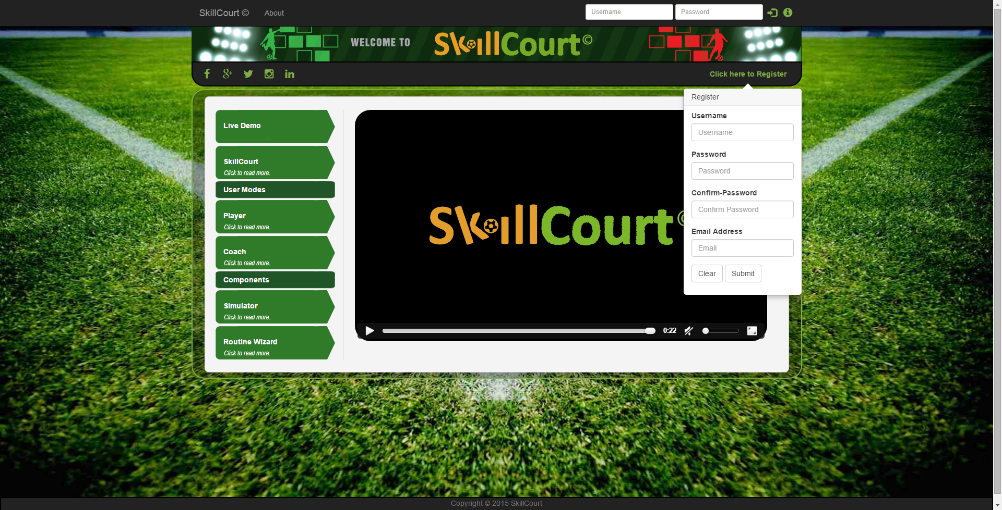

1. Now lets go ahead and enter all of your information. It is to note, that you cannot use an email address or username that has been used in the past.
2. Click Submit
3. Now you will receive an email address to the email address you just entered. Confirm the email address and go back to the SkillCourt site.

### Profile Page

Here you will be able to see your Personal Information, Athletic Profile, and Various Info.

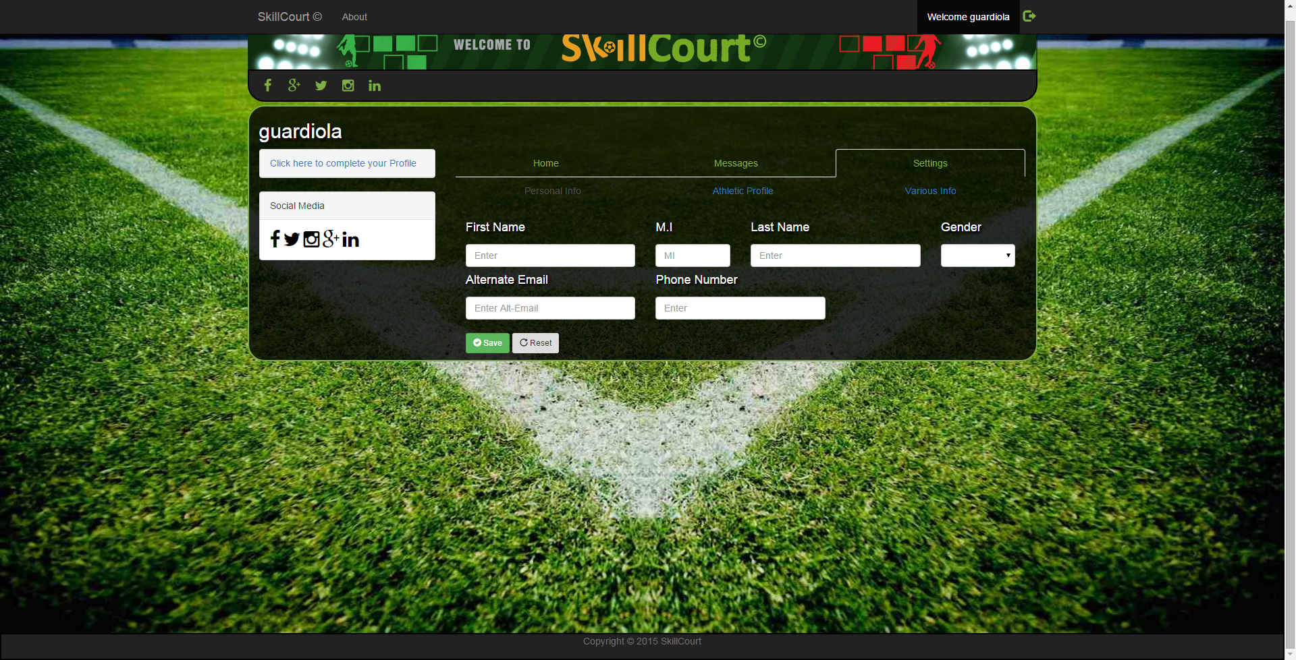

Before we continue, lets complete our profile by clicking on the Settings tab.

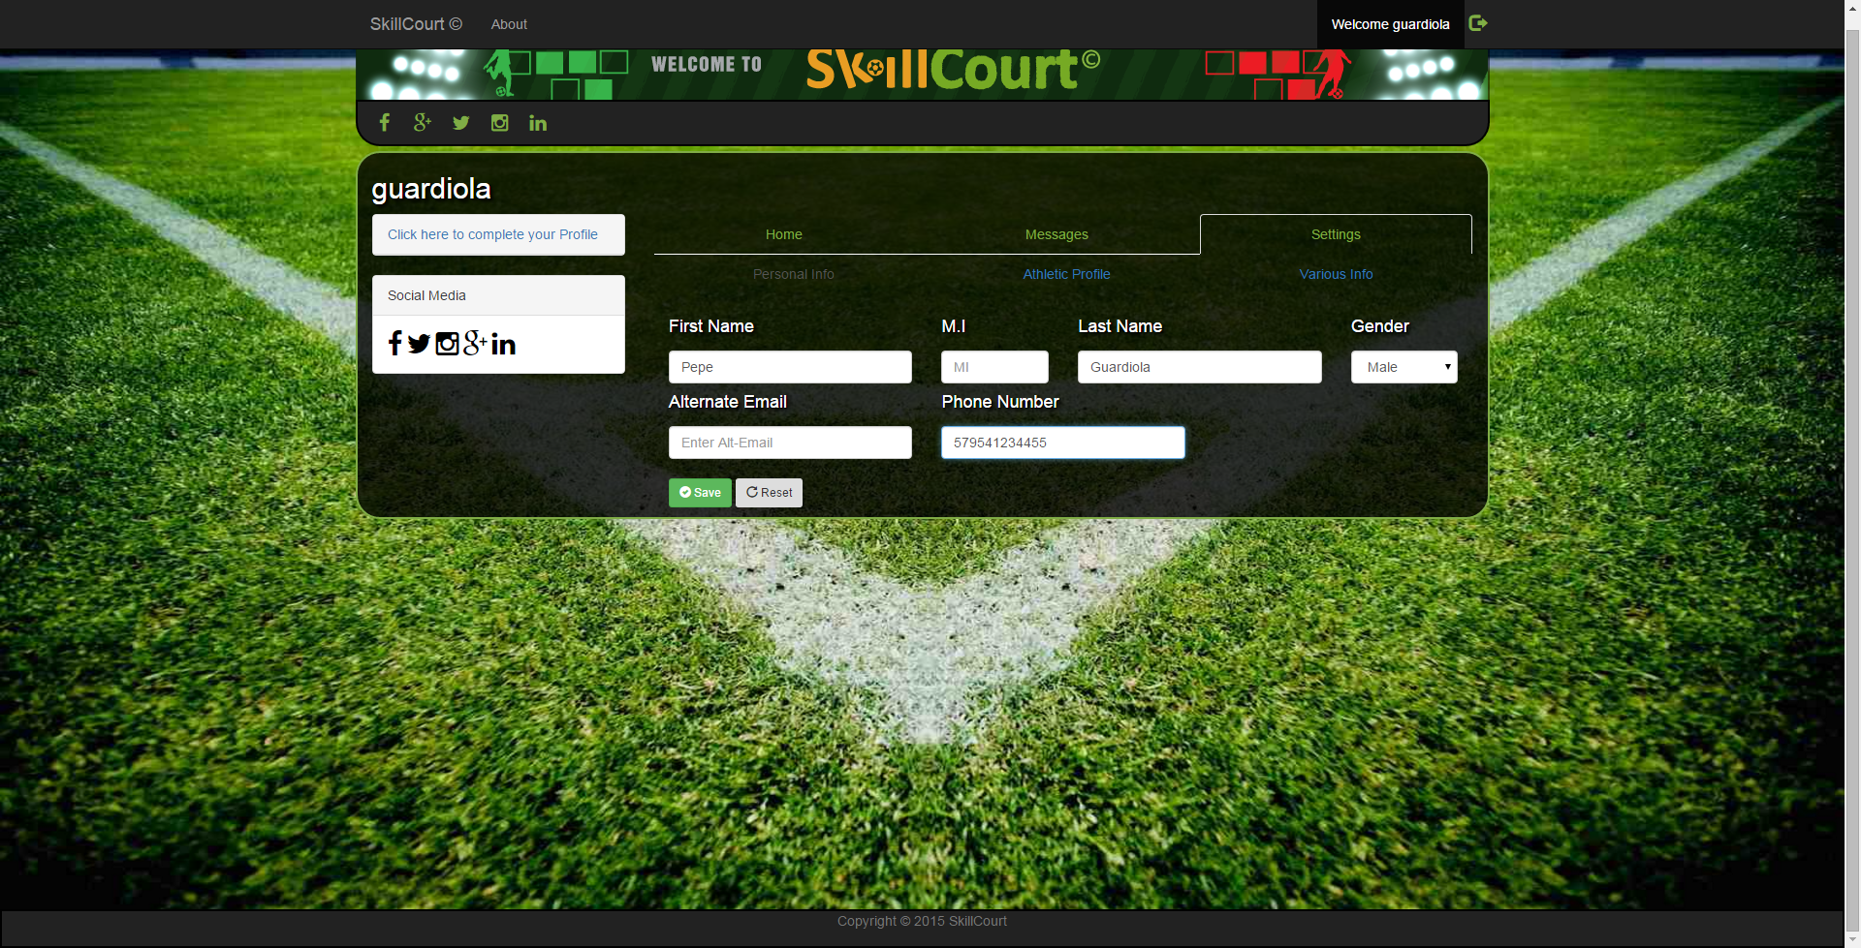

Enter your First Name, Last name, Gender, and Phone number. These are the only required fields.

**Once saved. We can see the Personal Information box show up on your profile pane.**

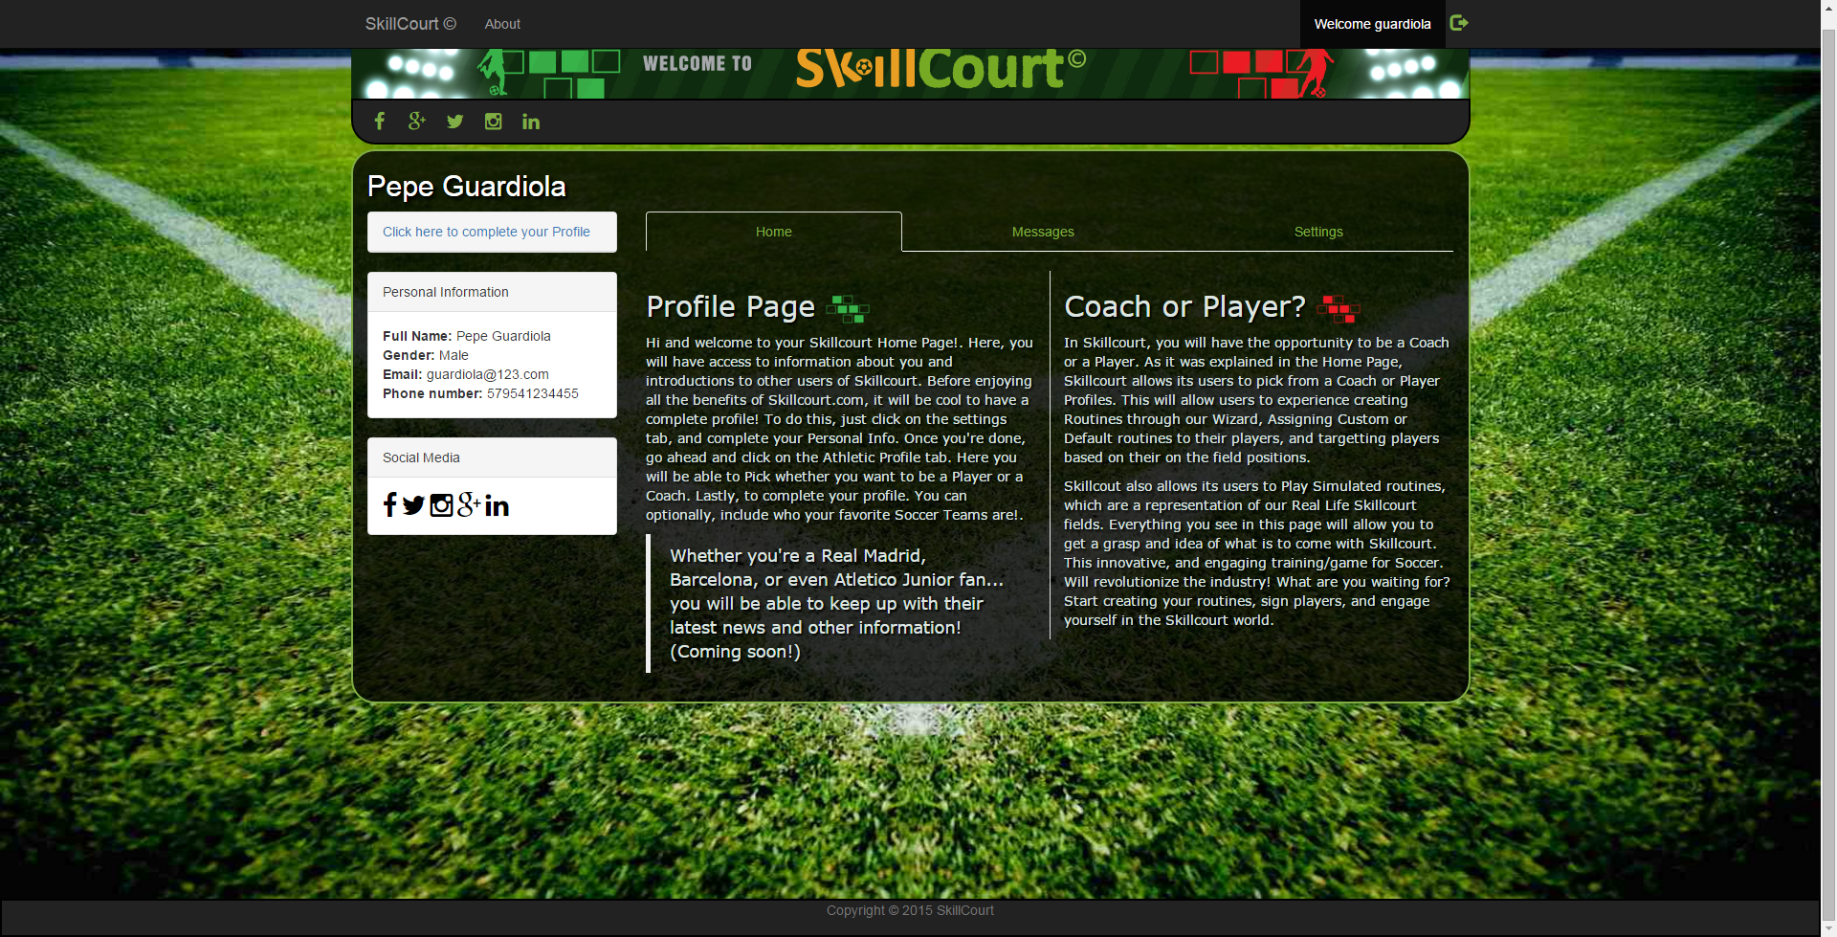

Lets continue by choosing what type of User we will be using.

1. Click on the settings tab
2. Click on the Athletic Profile tab
3. And complete your information as a Coach.

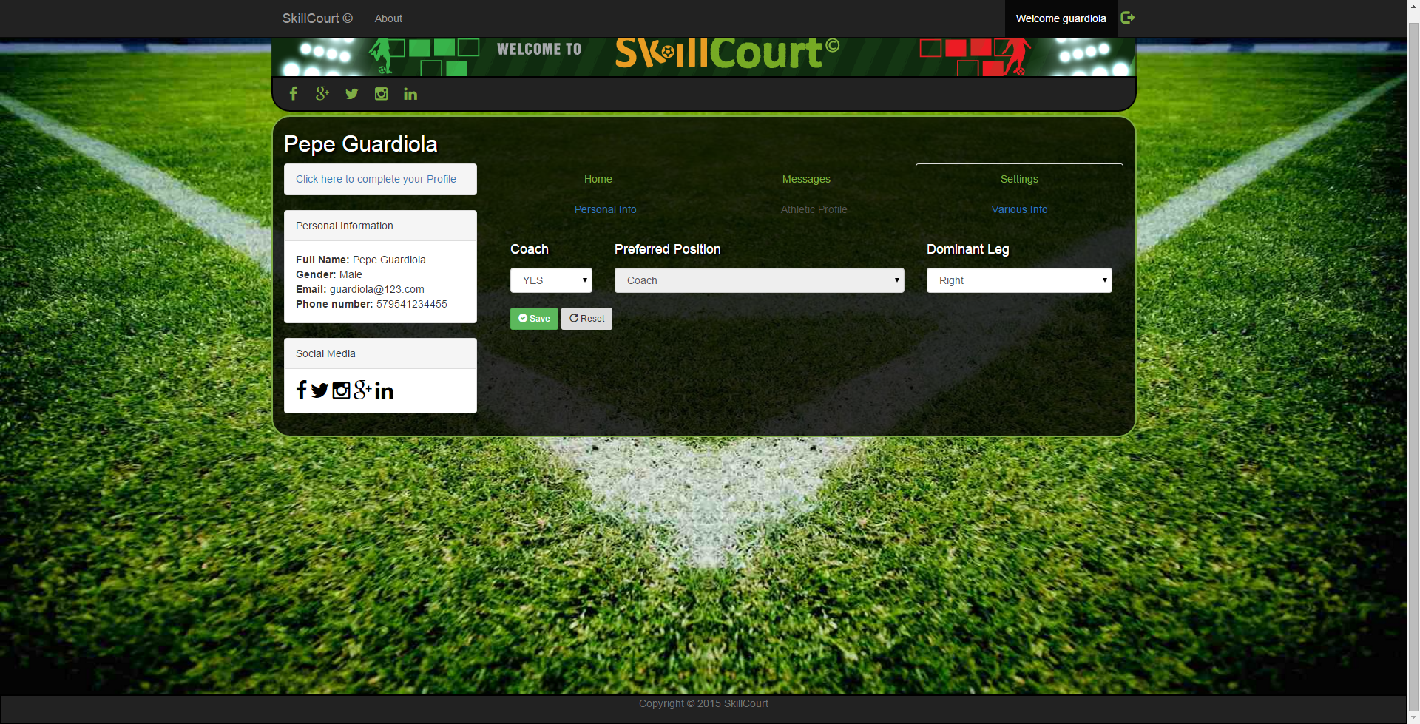

1. Once completed. Click on the save button, and 3 new links will show up on the top navbar.

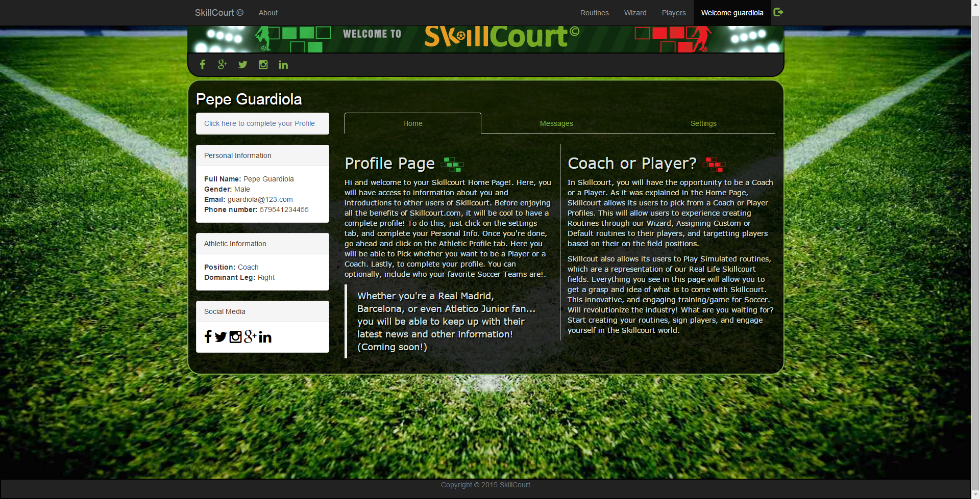

### Create Routines

In the Routines page, we are able to create Custom and Default routines. Let’s go over how to create a custom routine.

1. Click on the Routines link
2. Now lets complete a simple custom routine by clicking on a number of pads, clicking save step, and creating another step.
3. Lets finish it by clicking on the Finish Custom Routine button.
4. We will now enter a name for our custom routine and a description
5. Click the Complete and we have now been redirected to the Routines page.

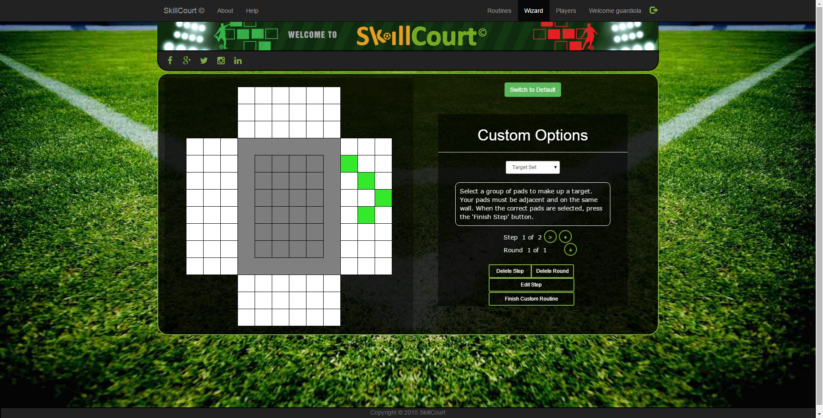

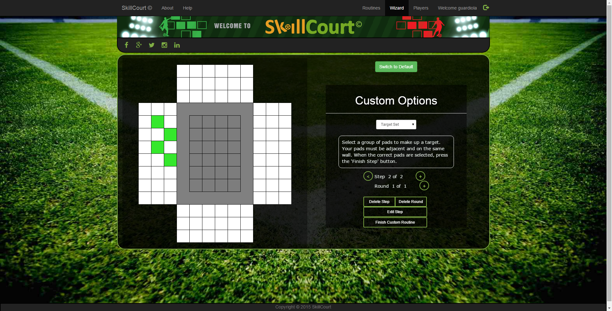

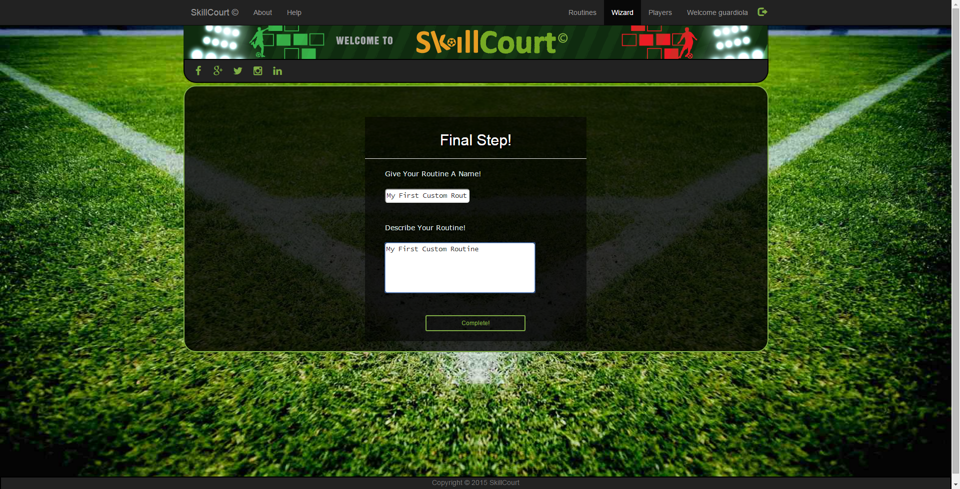

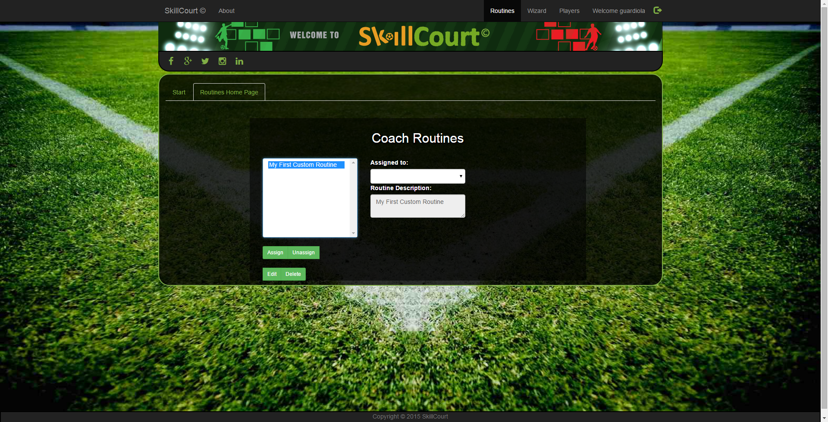

### Sign Players

As a Coach in SkillCourt you are able to sign players whom you will be able to assign routines to.

Let’s go ahead and sign a player.

1. Click on the Players link
2. Click on the Select Players link
3. Now lets access the Sign/Release Players tab
4. Here we able to query players by First Name, Last Name, Email Address, username and position.
5. Let’s filter by Position, and pick Attacking Midfielder.
6. Click on the Sign button.

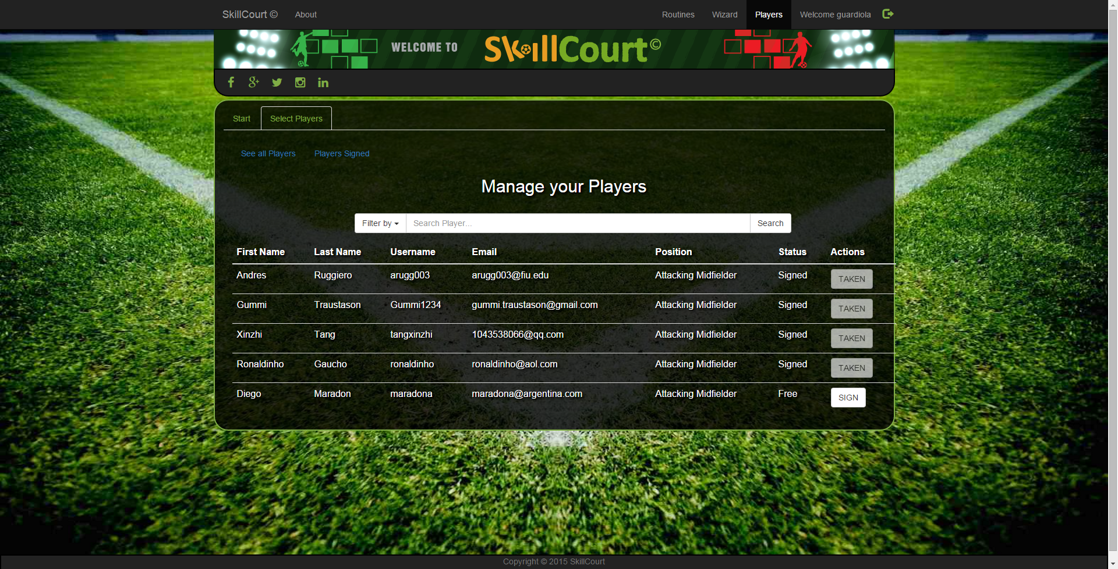

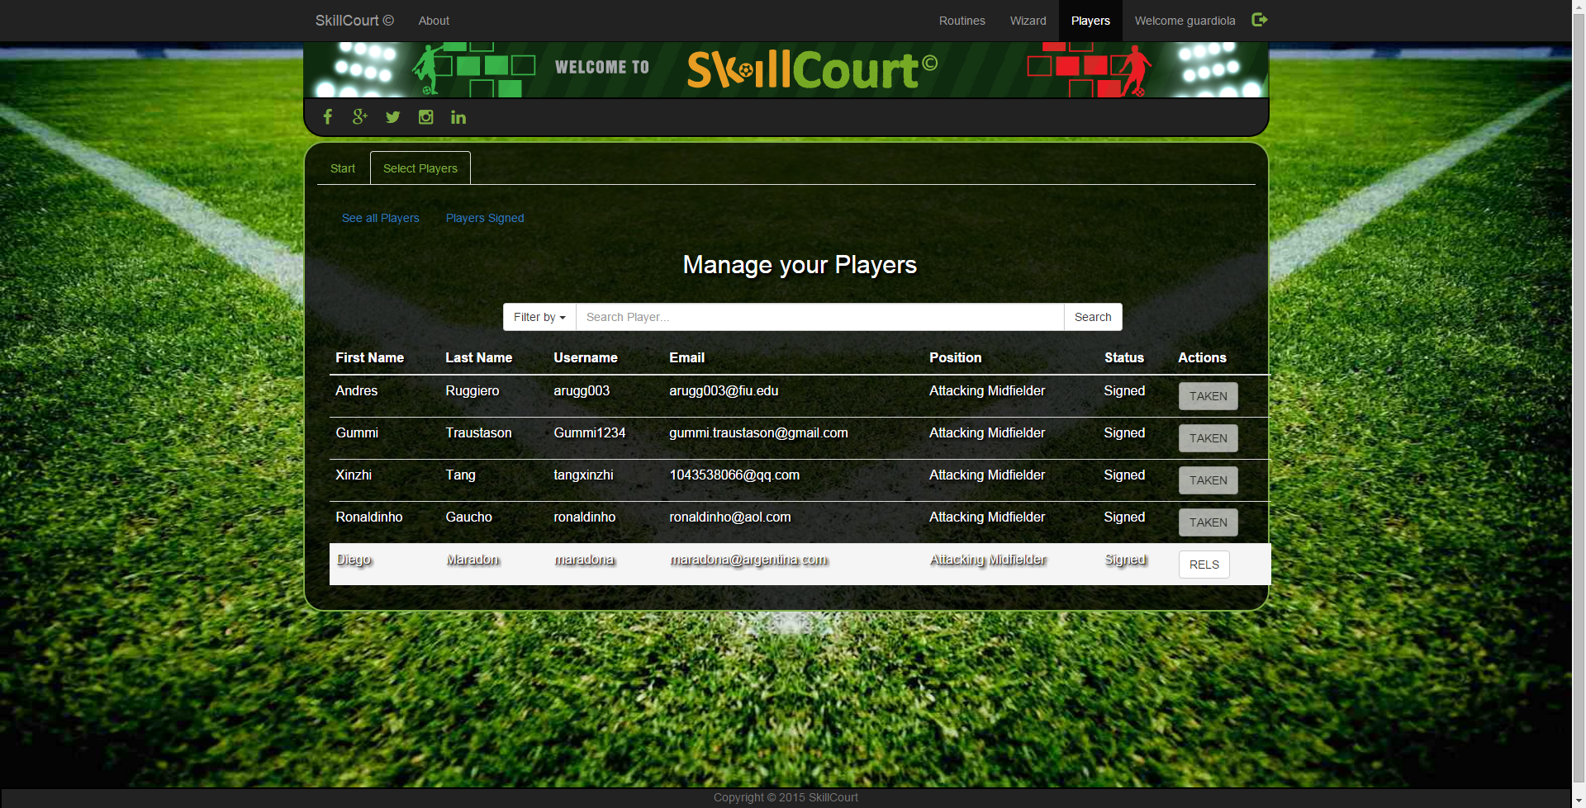

### Assign Routines

As a Coach, you are also able to assign routines previously created to your signed Players.

1. We will start by accessing the Routines page
2. Then Click on our previously created routine.
3. Click on the Assign button
4. Click on a Player, and click on the Assign button

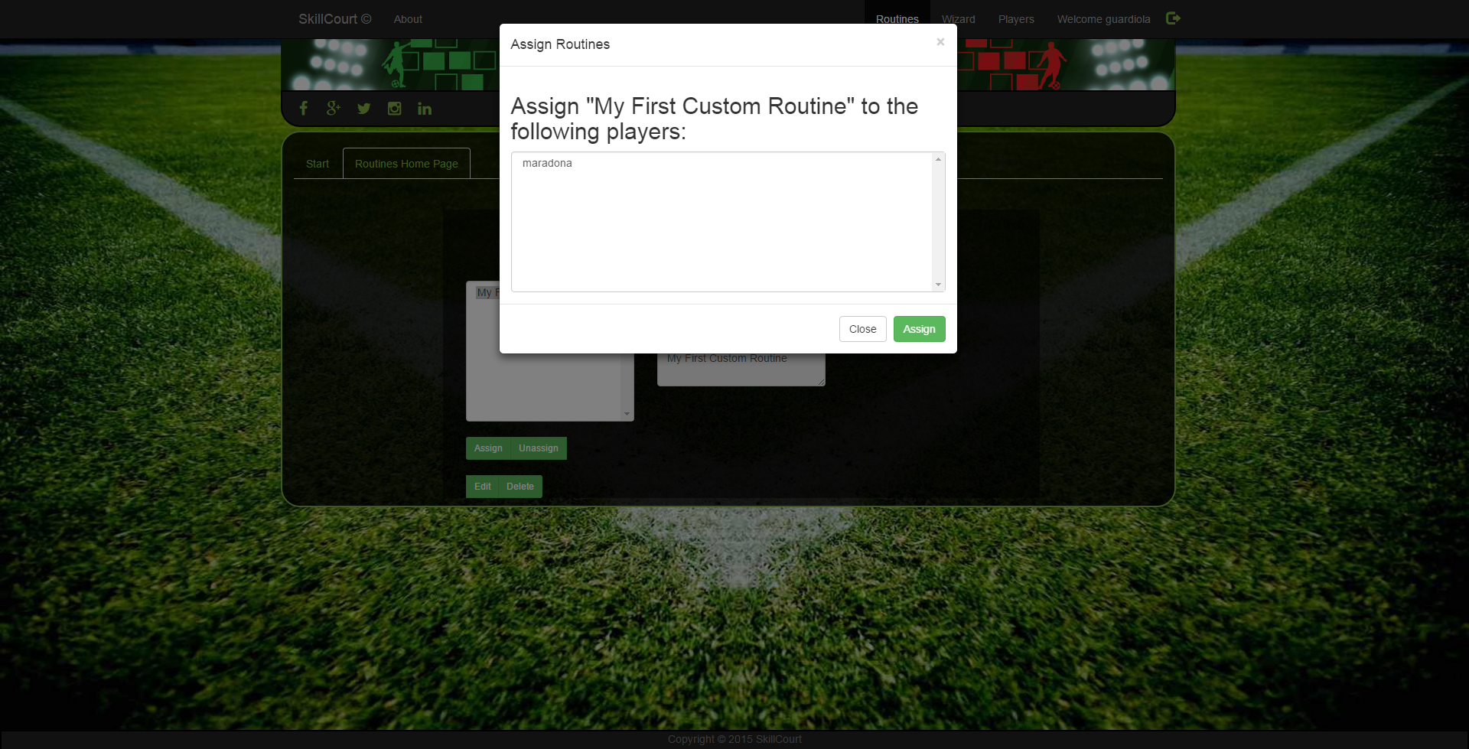

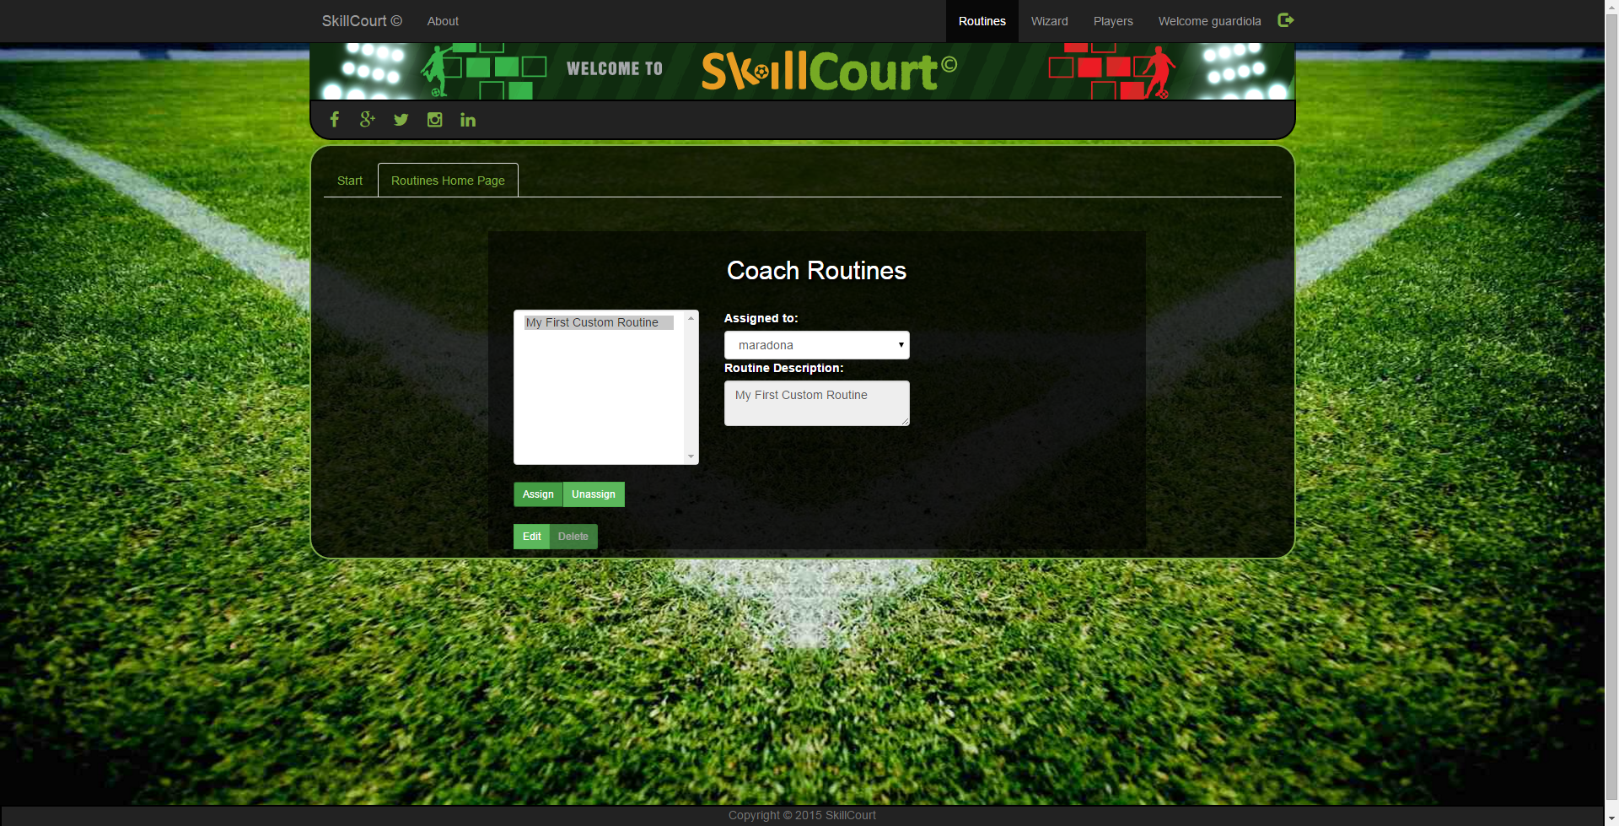

### Unassign Routines

A user is also able to unassign routines from previously assigned routines. Lets go ahead and go over how to unassign routines.

1. Click on a routine that has players assigned to it
2. Click on the unassign button
3. Click on the player we would like to remove from this routine
4. Click the unassign button.

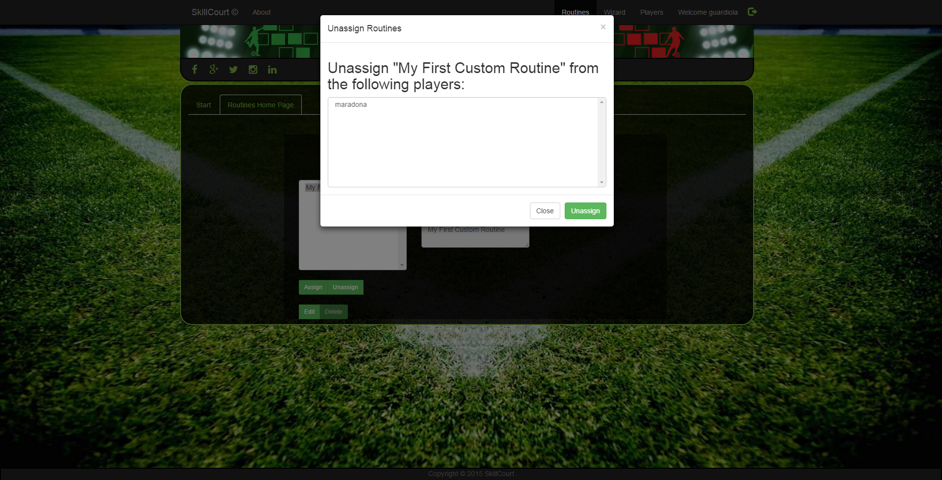



### Edit Routines

A user is able to edit previously created Custom or Default routines. Let’s go over how to do this.

1. Click on the routine you would like to Edit
2. Click on the Edit button
3. Add or Remove steps/rounds, and click on the Finish Editing button

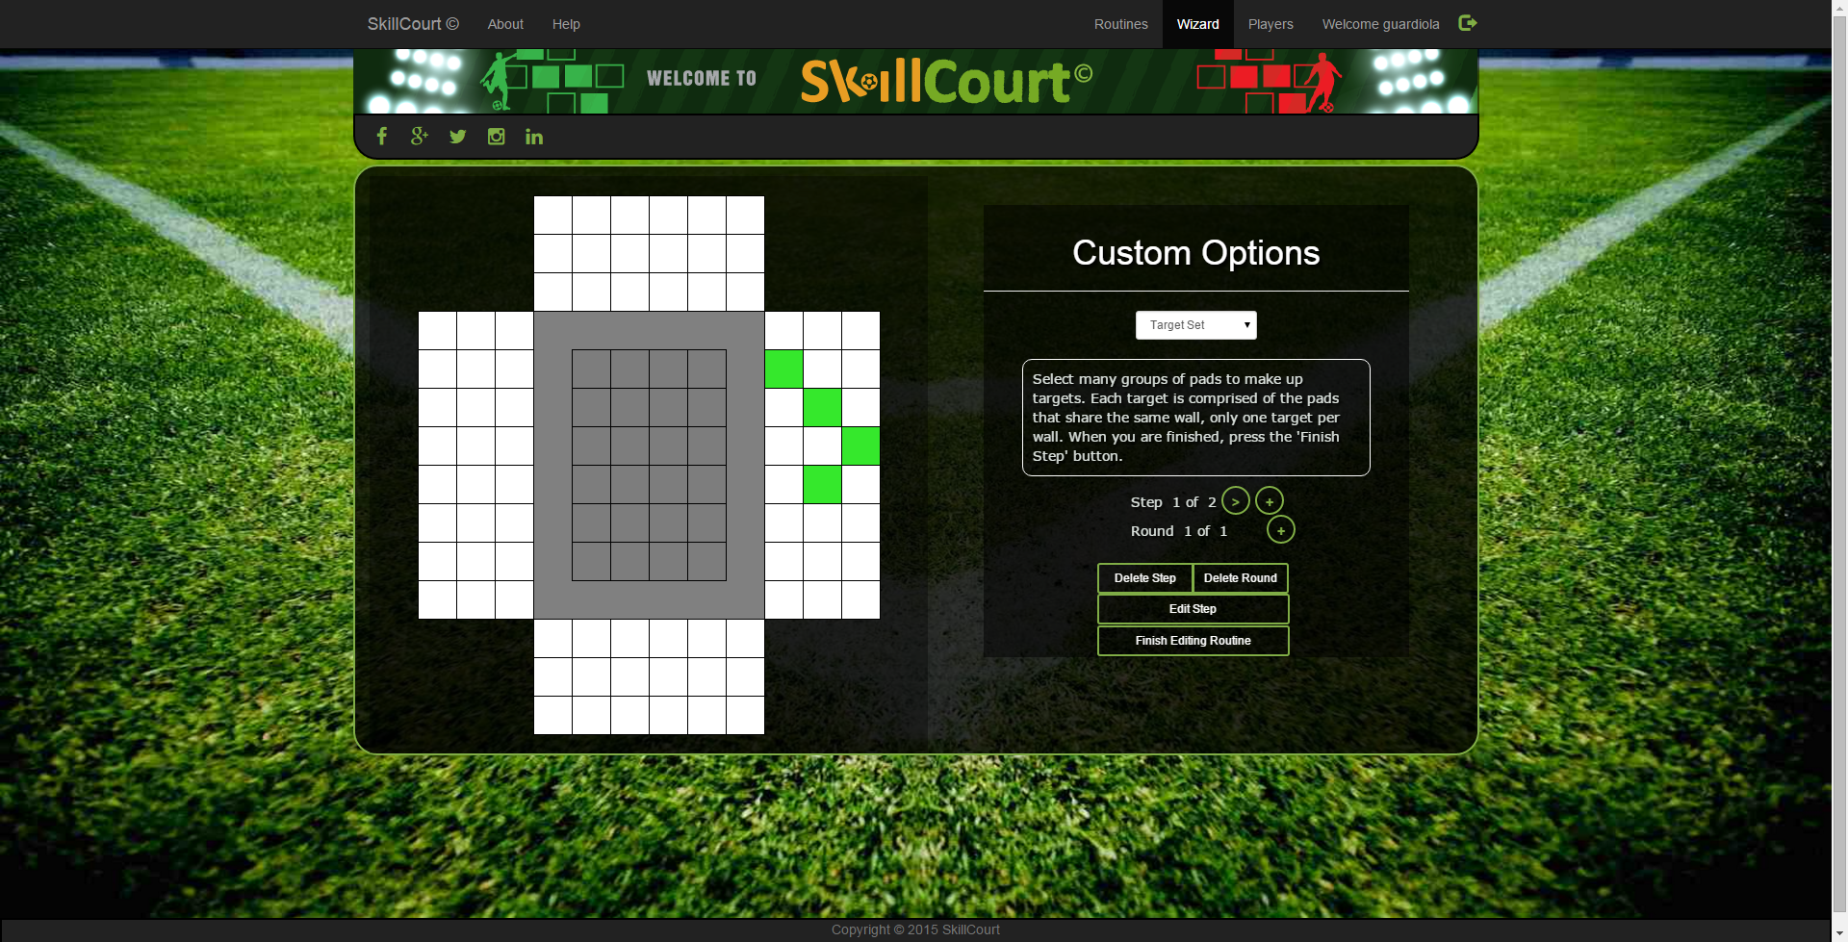

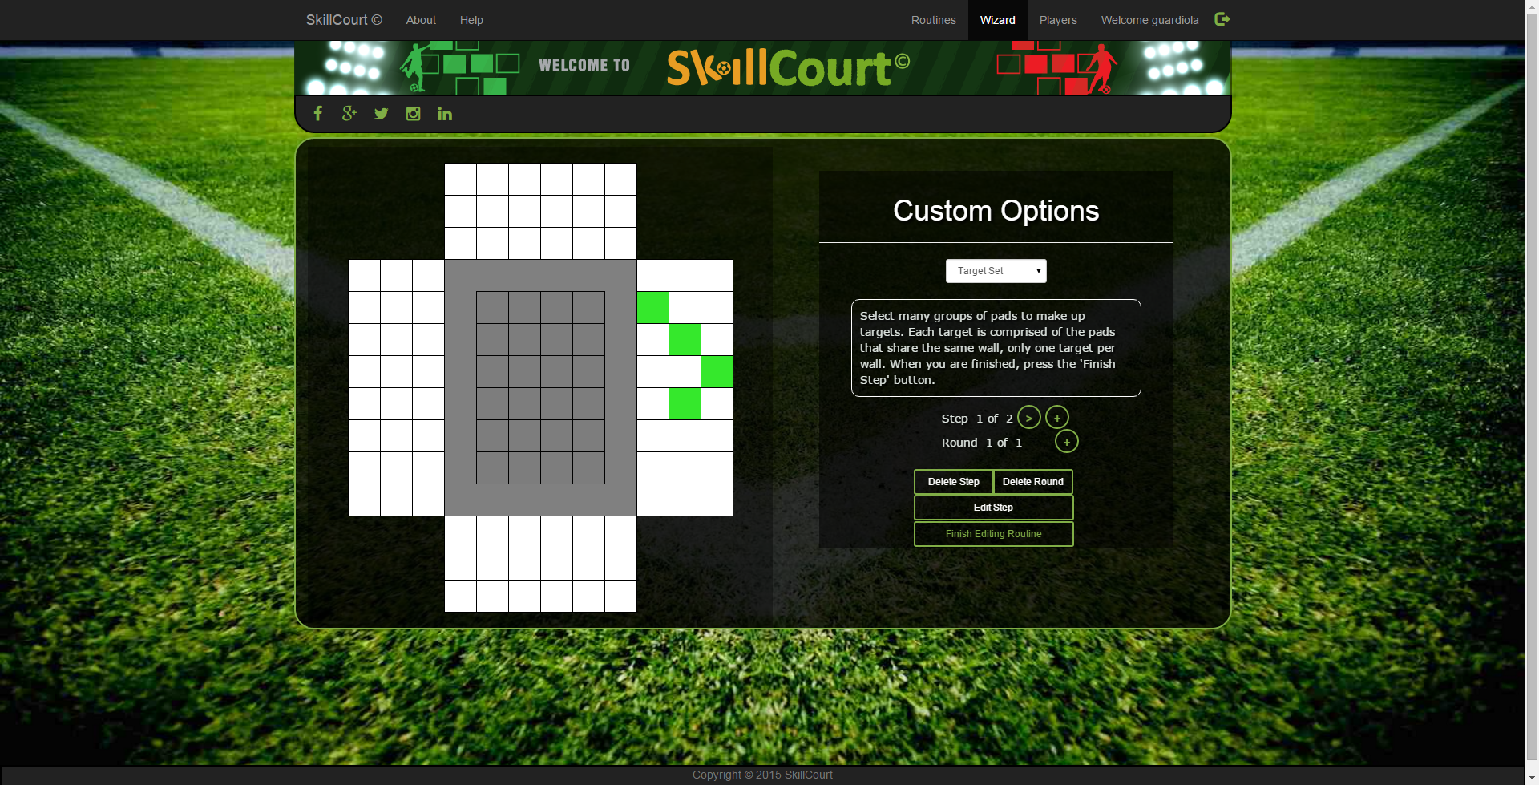

### Delete Routines

Lastly, a user is able to delete routines whom do not have any players assigned to them. Let’s go over how to delete routines.

1. Click on a routine with no players assigned to it.
2. Click on the Delete button
3. And click accept.

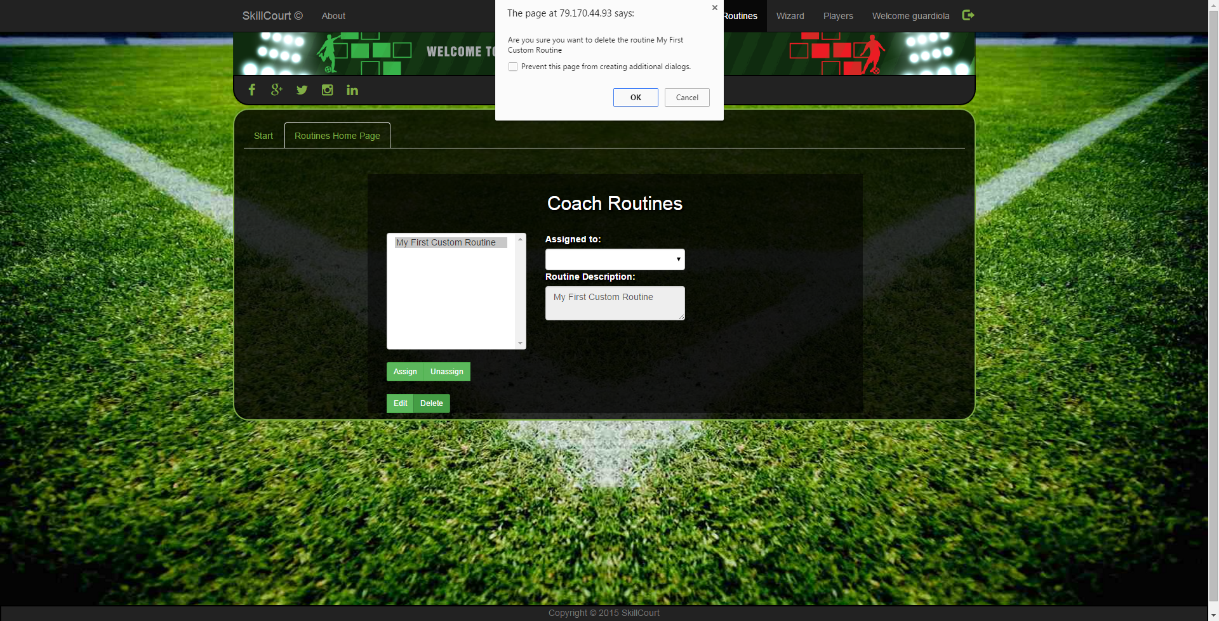

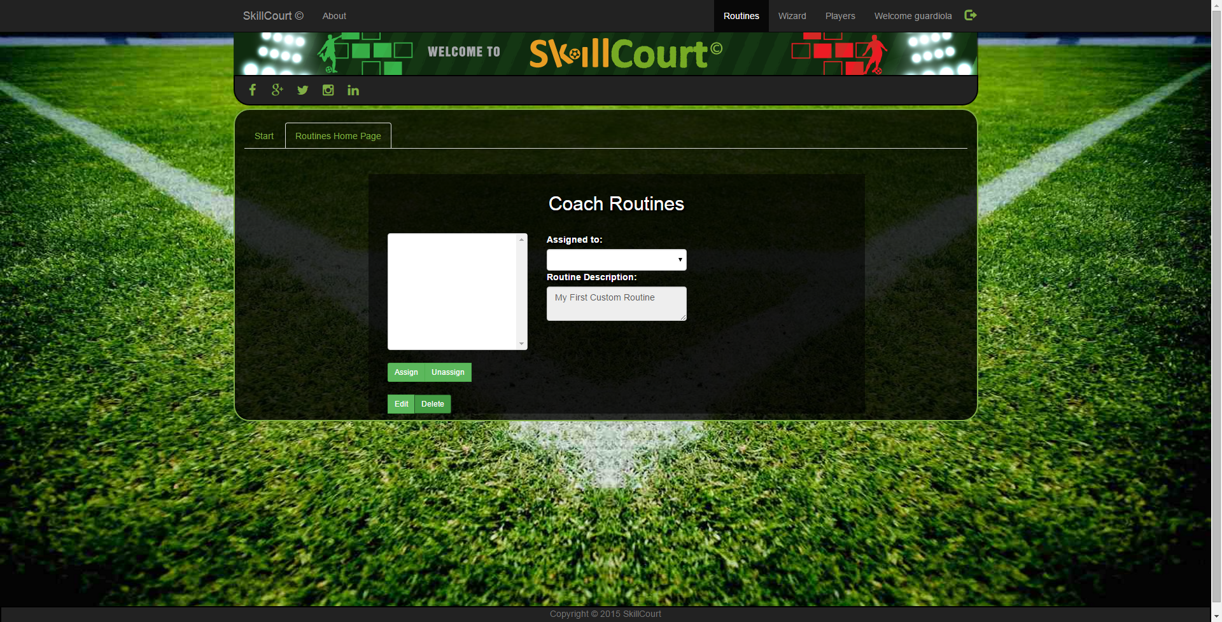

## 3. Manage Account Information

A user has the ability of resetting their password, by clicking on the info button right next to the login button. It is to note, that the system will not allow you to send a request to reset your password if the imputed email address does not exist in the database.

